**Jaweriya Younus  
2112182  
Talal Hussain   
2112102  
BSCS 8C  
Devops Git Hub Lab  
  
  
  
Download and Install Git Bash**

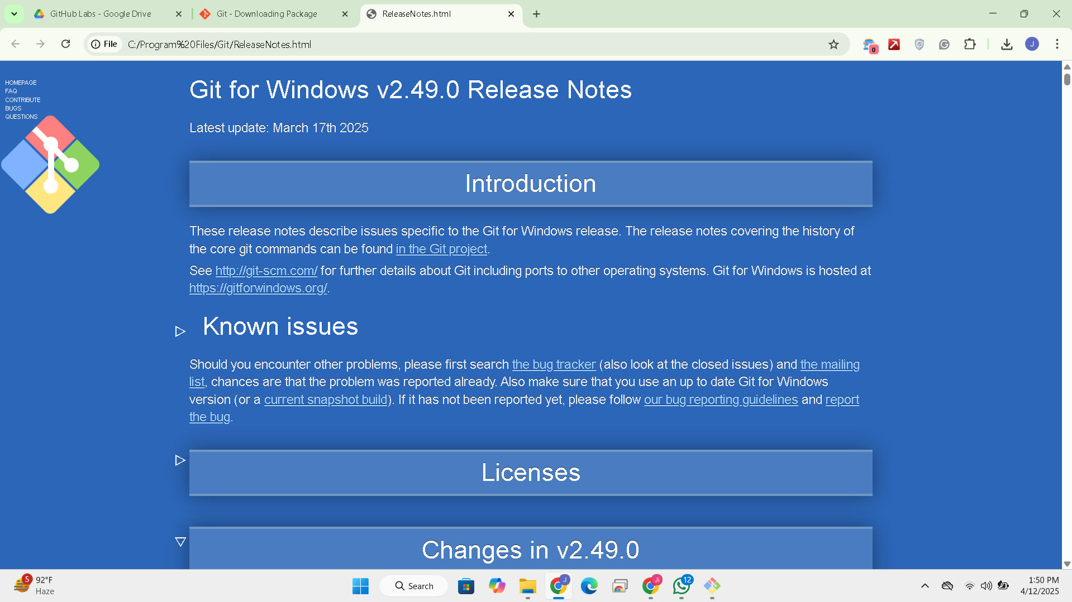

**Initialize Git with your Identity**

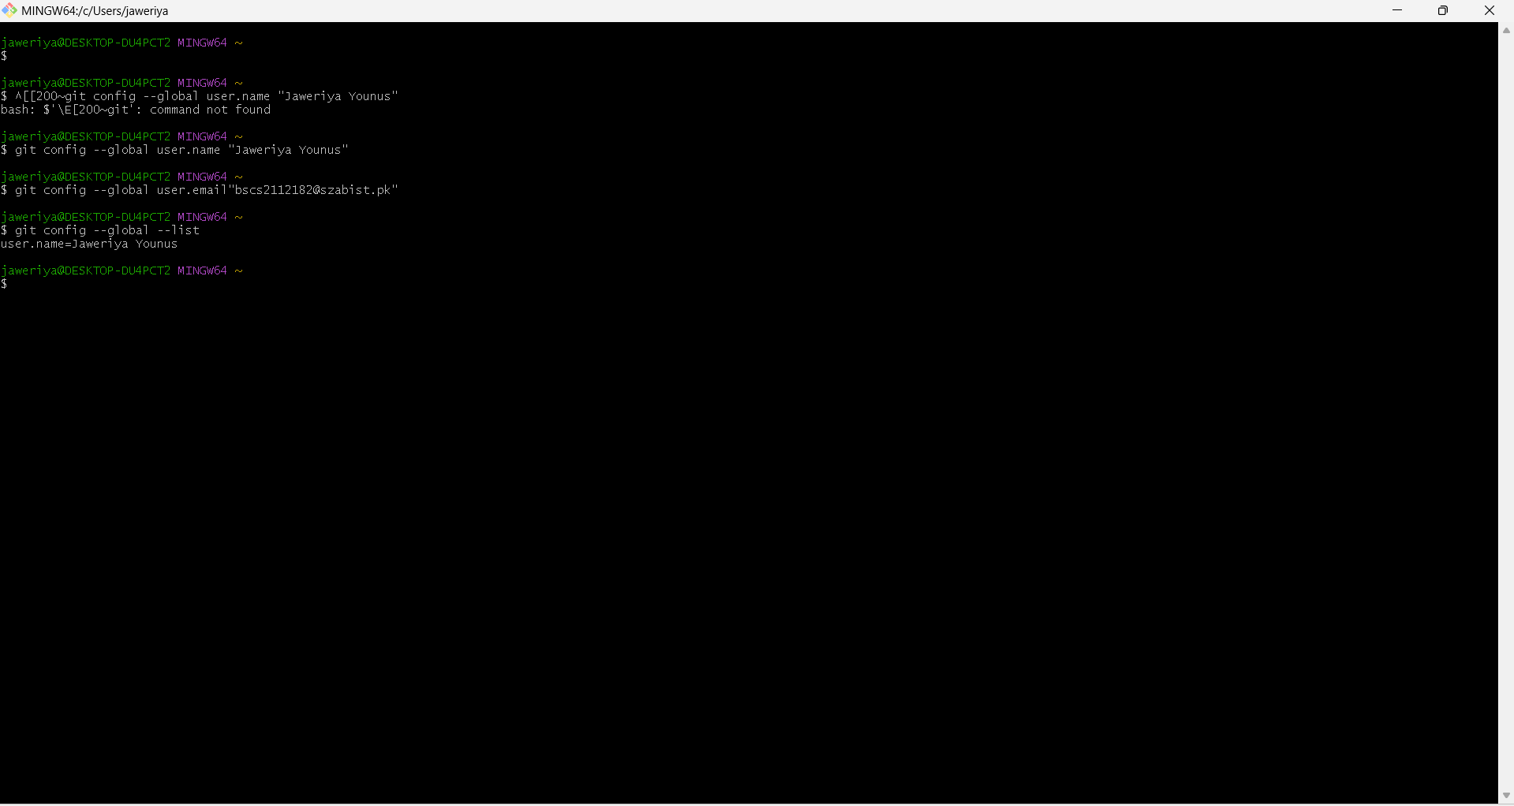

**Generate SSH key**  
**Test the connection**

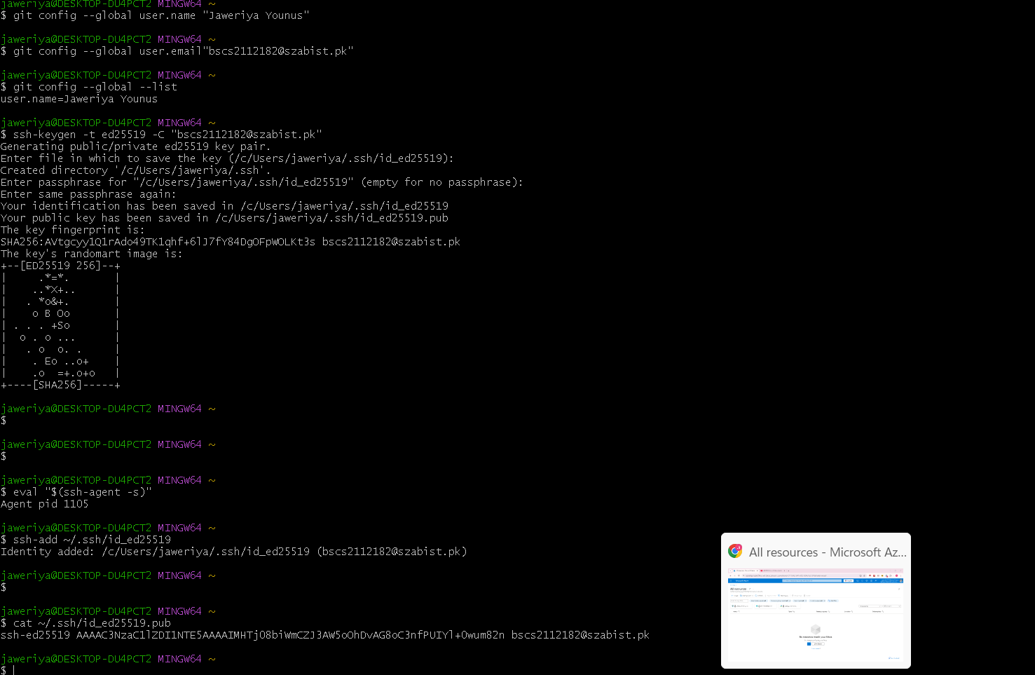

**Create Git hub repository**

**Clone Git Hub Repository**  
**Make Changes Locally  
create intro.txt  
edit it in editor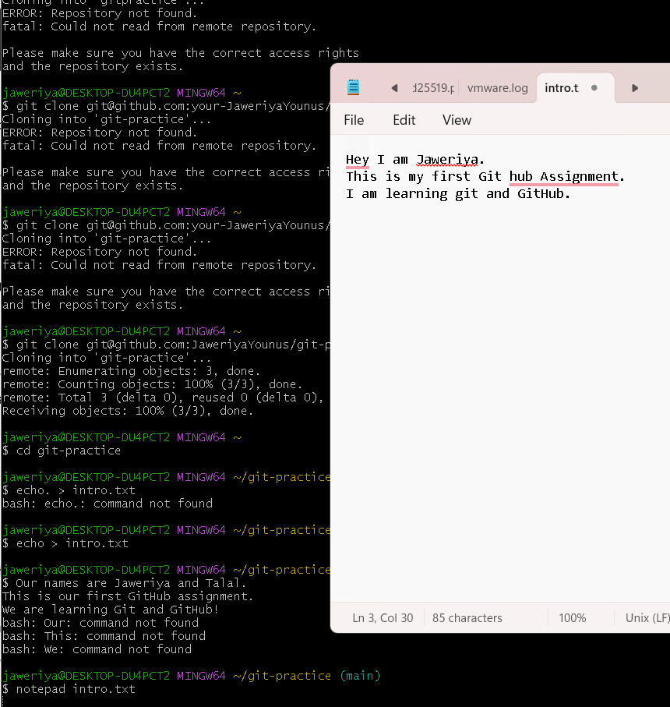  
check status  
stage the file  
commit**  
  
**Push to git hub  
  
check to see on git hub  
 Create a branch and edit intro.txt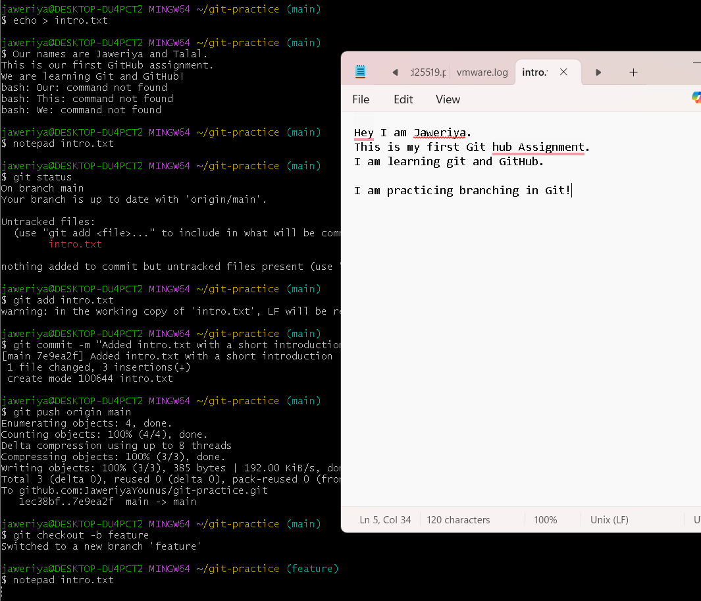  
stage and commit  
  
push the branch  
  
Pull Request**

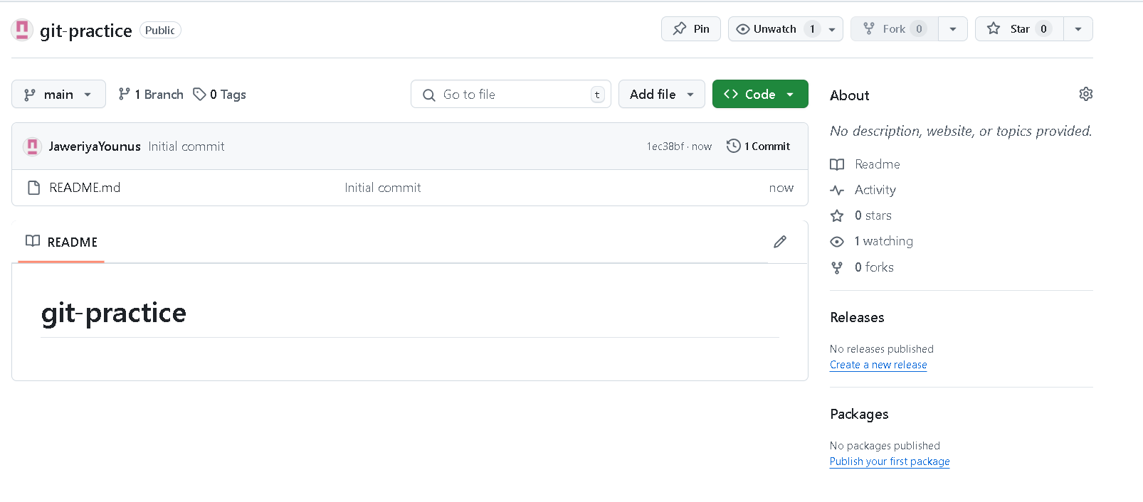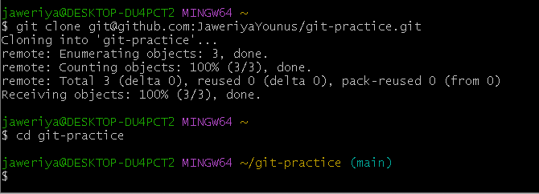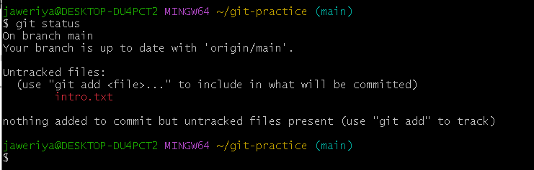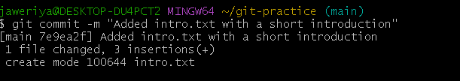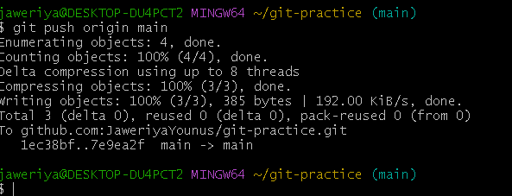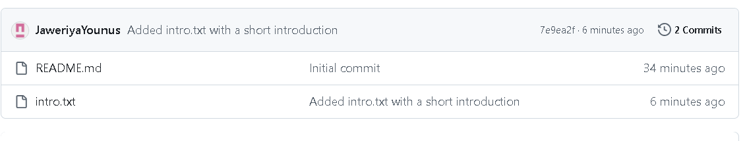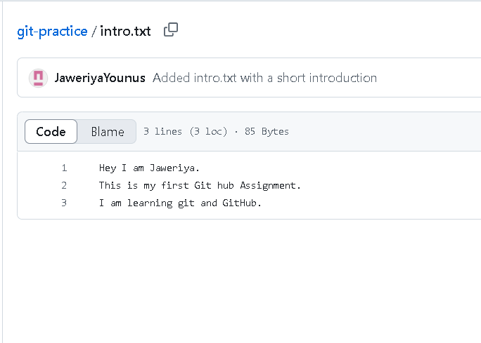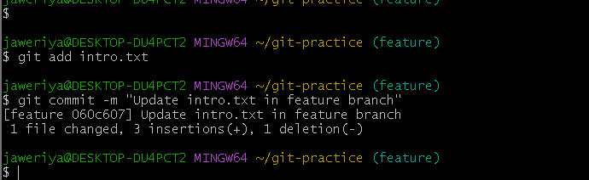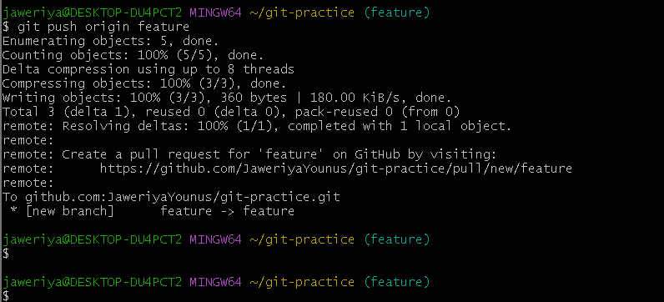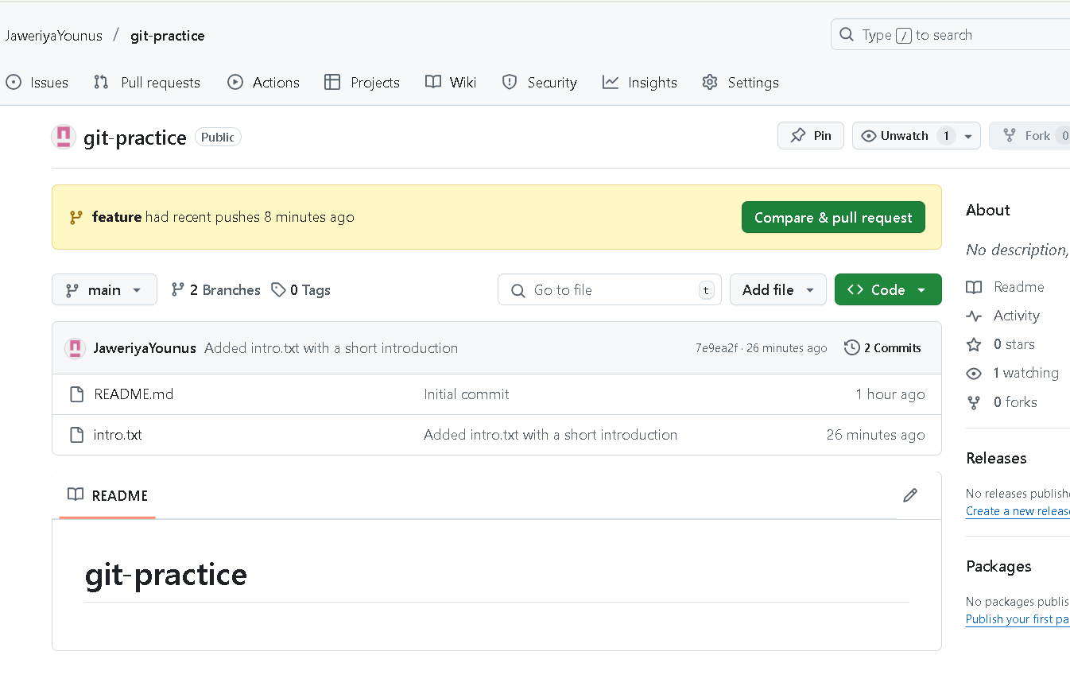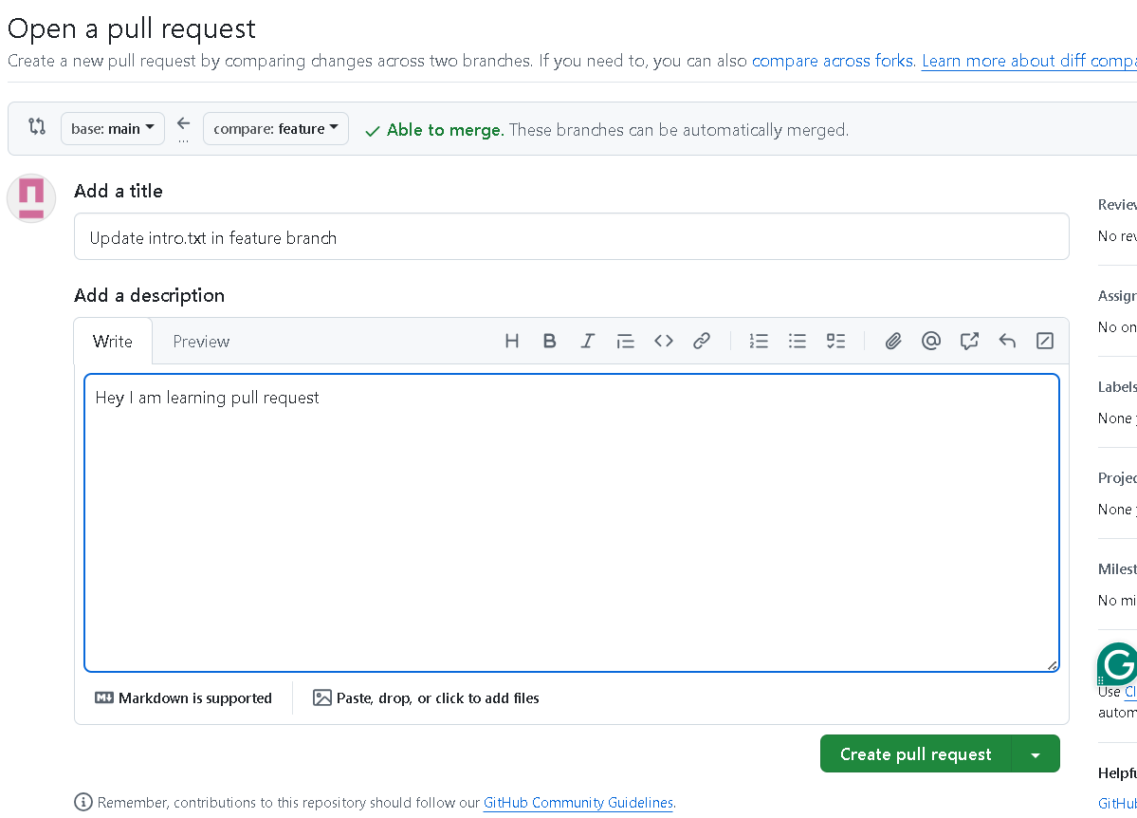

**Merge the request**

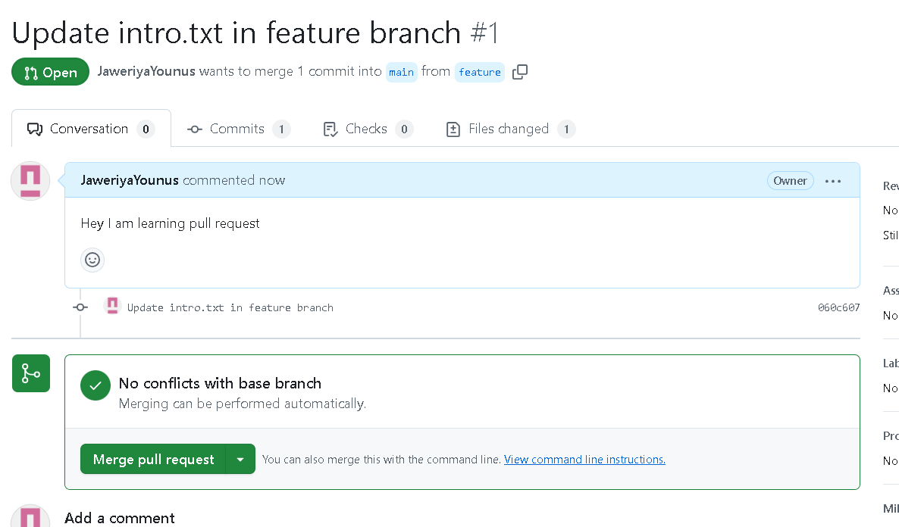

**Delete Branch**

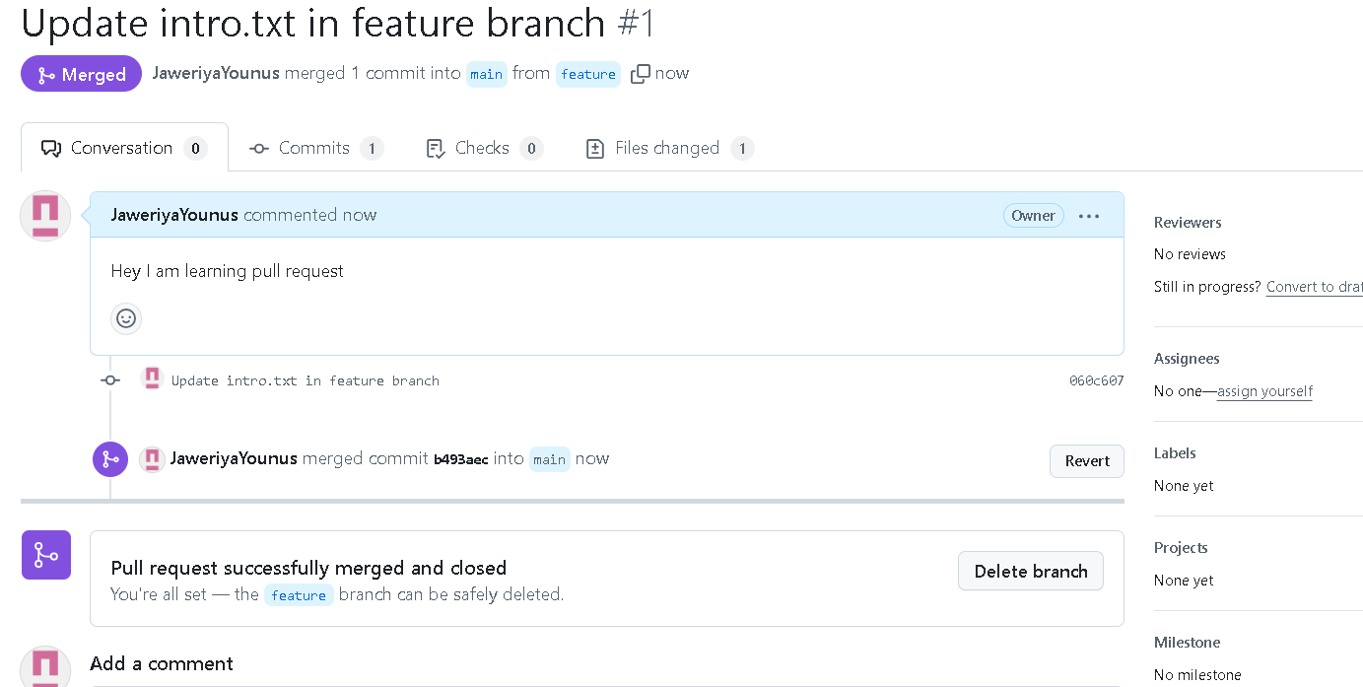

**Branch Deleted  
Sync local repository**

